

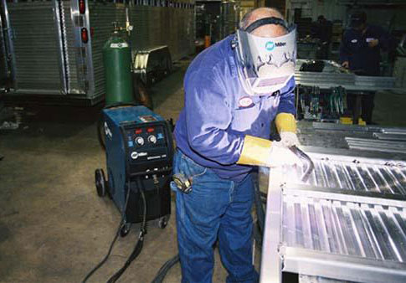

COMPANY **PROFILE**

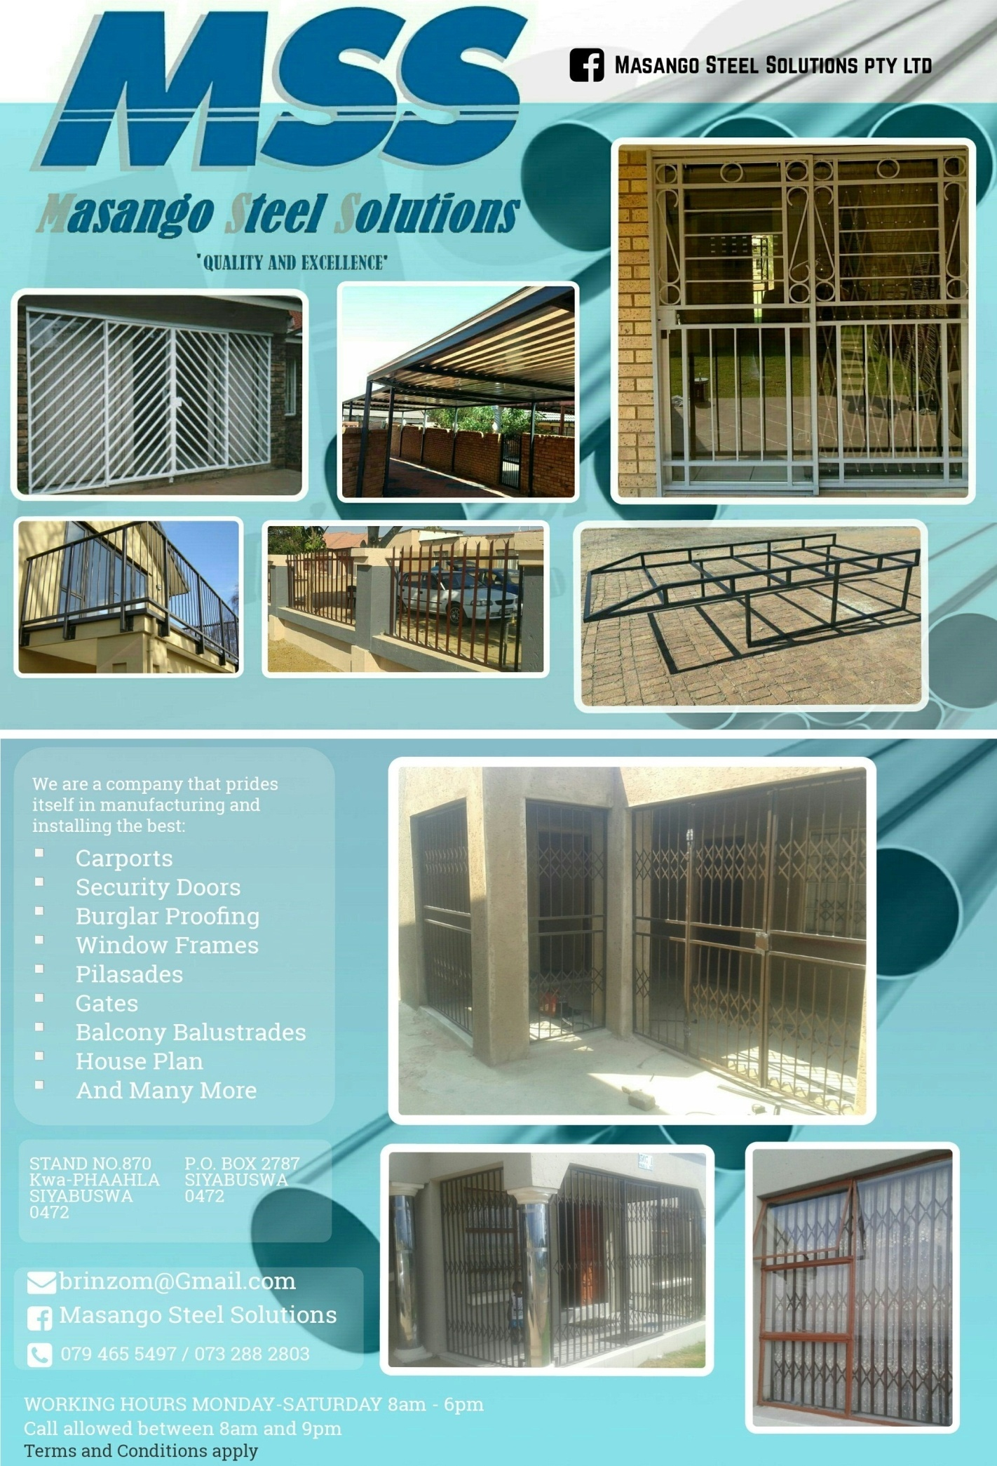

**COMPANY DETAILS**

**Physical Address:** 870 Kwa-Phaahla, Siyabuswa, 0472, Mpumalanga, South Africa.

**Postal Address:** PO Box 2787, Siyabuswa, 0472

**Main Director:** Mr. Brilliant Masango

**Tel No.:** (079) 465 5497

**Email:** [brinzomm@gmail.com](mailto:brinzomm@gmail.com)

**Company Reg No.:** 2016/537465/07

**Tax No.:** 9314654196

**Facebook:** Masango Steel Solutions Pty Ltd

**Bank:** FNB Business Banking

**Account Type:** Business Account

**Account Name:** Masango Steel Solutions (Pty) Ltd

**Account Number:** 62663546920

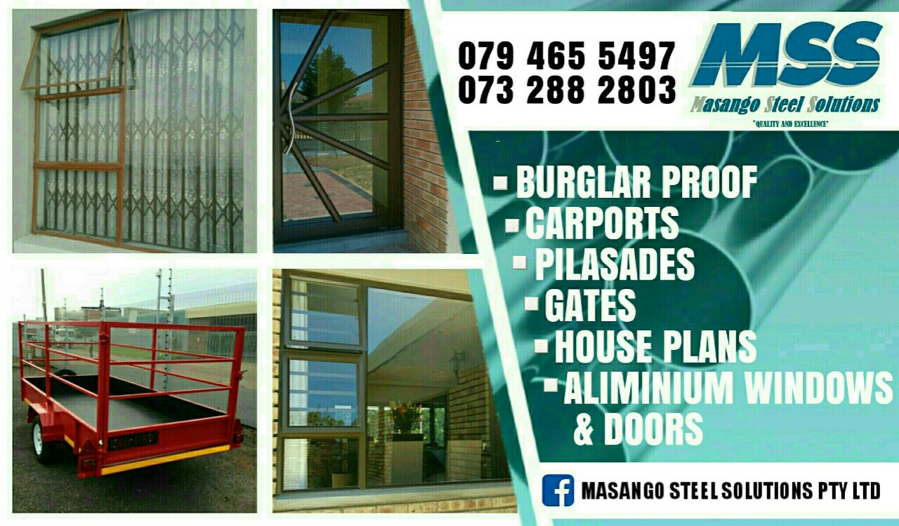**Branch Code:** 250655

**MSS: Manufacturers and Suppliers of:**

* Steel windows frames
* Gates
* Aluminium windows and doors
* Pilasades
* Steel Balustrades
* Carports
* Trailers
* Burglar proofing
* Installation and service of all aluminum products.
* We also manufacture and customize any steel product to your specifications.

We take this opportunity to introduce ourselves as one of the best Welding and Fabrication Company developing a fully-equipped facility. Our workshop is equipped with modern and advance technological machinery for manufacturing steel products.

The merit of our company is to offer a comprehensive service **(Fabrication & Supply)** in the field of structural services. We can ensure timely project completion, end-to-end quality management and budget control.

Our every employee believes value engineering is an important part of our work, and we provide solutions, not just products. Our teams of qualified, experienced welders can create and build to client specifications, whatever the challenge. Our clients are ensured the highest levels of product quality and workmanship including on-time completion.

**Our mission** is to provide high quality service/ product combined with trusted client partnership, and to maintain high health and safety levels and solutions to the client’s need.

**Our values**

• Quality and safety first

• Monitoring continuous improvement through learning and development

• Innovation and creativity in solving problems

• An empowered, committed and motivated workforce

MSS is confident that it can meet any required standard in the final product and service delivered. Resource allocations are continually evaluated to ensure that there is additional capacity for any work that needs to be done in order to complete projects successfully and on time.

Hope, that we will get an opportunity to work with your esteemed organization and prove our excellence to build a long-term relation for the future.

Thanking you

Yours faithfully

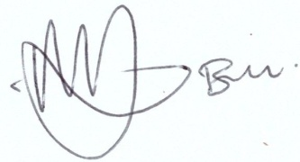

**Brilliant Masango**

**Managing Director**

**Contact : (079) 465 5497**

**OUR QUALITY POLICY**

Every employee of **MSS** shall ensure the satisfaction of our customers by providing them with the best value in every product and service that carries the name of **MSS.** **MSS** will create and retain satisfied customers, offering for sale products or services, which respond to customer’s expectations. Our customers will be supplied with products and services of a given quality, to be delivered by or be available by a given time, and to be of a price which reflects value for money. The policy of the company, for the manufacture and construction of the work and the services it provides, is clearly defined and meets the requirement of quality.

**MSS places particular emphasis on:**

• **Operation and maintenance of a safe system of work.**

• **Consistent achievement of the specified quality.**

• **Economy of manufacture and construction activities.**

• **Provision of Instruction planned to suit identified needs.**

• **Adherence to programmes with best practices, and to comply with all applicable requirements.**



**Managing Director**

Brilliant Masango

**Health Safety and Environmental Policy Statement**

MSS is committed to the health, safety and well-being of its employees, clients, subcontractors and all others that may be impacted by its operations. MSS is also committed to the protection and improvement of the environment in which it operates.

MSS will conduct all its work in accordance with the statutory or national requirements of RSA.

MSS recognizes that good health, safety and environmental performance is paramount and, therefore, will provide all necessary funding to carry out its activities to ensure that all risks are minimized.

It will achieve this by:

• Eliminating hazards, conditions and situations that give rise to potential accidents. Where this is not practicable then measures will be put in place to reduce these hazards to a manageable level.

• Training employees in safe working practices and ensuring that this knowledge is regularly updated.

• Consulting with employees’ representatives on the matter of health and safety on a regular basis and stressing that continuous improvement is the responsibility of management and employees alike.

• Providing a safe working environment which takes into consideration the necessary protection of employees with regard to access to machinery, safe working procedures and safe use of substances etc. Where this is not possible or practicable then protective equipment will be provided to protect against the hazards identified.

• Providing adequate first aid and fire fighting facilities, as well as accident prevention and health surveillance, to improve standards of safety and reduce accidents and lost time.

• Ensuring employees understand their duties under the health, safety and environmental legislation.

• Conducting its business in an environmentally sensitive manner, taking appropriate measures to avoid causing environmental damage and reducing environmental impacts to a minimum when these are unavoidable.

• Reviewing and revising this policy at regular intervals.

**Safety Officer**

Safety Officer is responsible for the implementation of the requirements of the Company’s Health, Safety and Environmental Policy in the area of responsibility.

**In carrying out these duties its main responsibilities are to:**

* Familiarize himself with the requirements of the Policy and ensure they are implemented.
* Ensure everyone is competent and give precise instructions regarding their responsibilities to ensure correct working methods are used.
* Where necessary seek the advice of the Safety Personnel on any matter relating to safety.
* Report all injuries, industrial health disorders and dangerous occurrences/near misses to the Managing Director.
* Ensure, where necessary, injuries and dangerous occurrences are reported to the Managing Director and are involved in accident investigation where required.
* Seek to set a personal example at all times.

**Employees**

***As an individual undertaking an operative task you are responsible for ensuring that you look after your own health and safety and do not cause problems to others***

In particular, it is the personal responsibility of each employee to use properly and conscientiously all safety equipment, devices and procedures and protective clothing and equipment that is fitted or made available.

All employees must:

* Carry out their work in accordance the safe working practices adopted by MSS.
* Work to instructions given by a person in authority.
* Always obey all Company and specific site safety rules.
* Wear any personnel protective equipment issued to them and ensure the equipment is kept in good condition.
* Work in a safe manner at all times. Do not take unnecessary risks that might endanger yourself and others.
* Not use equipment for work for which it was not intended.
* Report any defects in plant to a managing director immediately and ensure that it is in a safe and secure state when left unattended.
* Co-operate with the MSS in maintaining a safe working environment and suggest any ways for improving it.
* Keep work areas clean and tidy.
* Immediately clear up any spillages. Ensure all waste materials and rubbish are routinely removed and placed in the correct bins and skips.
* Report personal industrial injuries and/or diseases to the Managing Director. You must also assist in any subsequent investigation.
* Report any dangerous occurrences or near misses.
* Report to the Managing Director any person seen abusing the welfare facilities provided.
* Not play dangerous or practical jokes or "horseplay" on site.
* Not work under the influence of alcohol or drugs.

**Control of Noise**

Sources of noise likely to exceed occupational action levels will be assessed prior to commencement of works. Compliance with the Noise at Work Regulations will be achieved in accordance with the hierarchy of controls – i.e. reduction at source, provision of hearing protection and where practicable, establishment of defined hearing protection zones. Where appropriate health surveillance will be carried out. Environmental noise may be occasionally monitored at site boundaries to ensure that local limits are not breached.

**First Aid**

A managing Director will render first aid when necessary. Other employees will, in the absence of the Managing Director, be capable of taking charge in an emergency, calling an ambulance and looking after first aid equipment. A suitable number of first aid boxes will be provided and maintained and be located in positions which are easily reached by all employees. Display notices will give the identity and location of first aiders.

MSS shall provide one or more first aid boxes containing medicines, bandages, antiseptics, and such as other first aid material. There shall be first aid box for workers. The box shall be entrusted to a person to a specialized in giving first aid.

Every worker shall comply with the instructions and orders respecting industrial and personal safety precaution use the necessary protective devices and treat any such devices in his possessions with due care. It shall be unlawful for a worker to commit any act leading to non-compliance with such instructions, to the misuse of the equipment provide for protecting the health and safety of the workers or to the damage or destruction of such equipment. An employer may, include in the disciplinary code penalties to be imposed on workers contravening the previsions of the preceding paragraph.

**Welding**

Welding first aid will be organized to protect both the operative and others from the dangers of burns, arc eye and electric shock. All equipment will be fully insulated and conform to the latest standards. The operator will always wear adequate protective clothing to protect against burns, electrical contact between the welder’s body and his surroundings and against inadvertent contact with the ‘live’ welding electrode.

Fire extinguishers are to be provided where all welding activities take place along with welding screens to protect third parties from welding flash/arc eye. When and where required fire blankets to protect the surrounding area(s) will be provided.

**Occupational Health**

Employees are able to raise occupational health issues and the communication of known hazards made to all those that could be affected. Appropriate corrective/preventative measures are implemented and the follow-up action is taken to ensure improvements are implemented. Workplace inspections and job observations take place as necessary to assist in identifying regulatory medical requirements. Appropriate risk assessments are carried out where necessary.

**Work Equipment including Hand Tools**

MSS will ensure that work equipment is carefully selected, ensuring that it complies with the regulations, and that it will be properly maintained. Operatives will receive all necessary information, instruction and be aware of any foreseeable dangers.

MSS will also:

• ensure that equipment is properly constructed or adapted for the purpose for which it is used or provided;

• consider working conditions and risks to health and safety to persons where the equipment is to be used;

• ensure that the equipment is used only for operations and under conditions where it is suitable.

Managing Director shall ensure that operatives are provided with tools that are suitable for their intended task. All MSS operatives shall ensure that defective tools are reported to the Director for repair or removed from use.

**Young Persons at Work**

MSS will ensure that appropriate arrangements are in place for young people at work including those on work experience.

MSS will:

• Assess the risks to young people before they start work.

• Ensure that the risk assessment takes into account specific factors, including their immaturity, inexperience and lack of awareness. (This risk assessment will determine, with respect to work experience, whether the placement can go ahead).

• Introduce control measures to eliminate or minimize the risks.

Introducing Steel Windows

**For over a century, steel windows have been specified for a range of settings with their unique, timeless qualities being used to evoke classic, old-world themes or make bold, modern statements.**

**Long Lasting**

Original steel windows in buildings constructed at the beginning of the 20th century are still in good working order today. The advent of galvanizing in the 1940s has banished the spectre of rust which bedeviled earlier examples where maintenance was neglected during two World Wars. Hardware is still available to repair and renovate them, and their gradual evolution has ensured that sympathetic replacement is possible with modern high performance versions which retain a similar shape and style.

**Strong**

The strength of steel is a prime reason for its success as a window framing material. Steel framed windows, tested to the latest standards for resistance to racking and twist, exceed all recommended requirements and satisfy maximum class 4 ratings.

**Narrow Sightlines**

There is no quality more readily associated with steel windows than narrow sightlines. Their slender lines have been incorporated into all types of buildings over the years with an elegance which is rarely matched by the bulky profiles of aluminium, wood or pvc-u. The minimalist aspect of steel windows derives from the superior strength-to volume ratio of the material.

**High Thermal Performance**

The slender lines of steel frames enhance the glass-to-frame ratio. As the thermal performance of windows is dictated more by the choice of insulating glass than the material of the frame, even solid hot-rolled steel windows can demonstrate compliance with the energy conservation requirements of the Building Regulations. Thermal barriers within cold-formed tubular profile frames provide advanced solutions to the most demanding needs for thermal insulation.

**Safe and Secure**

Steel is the first choice for keeping intruders out. Steel windows and doors offer superior resistance to impact from accidental collision as well as proven solutions for fire resistance of 30, 60 and 90 minutes with respect to integrity only or integrity and insulation.

**Sustainable**

The source of steel billet, rod and strip, from which steel window profiles are formed, is basic steel smelted from almost 100% recycled steel scrap. The hardware, generally of brass or rust resistant steel, has evolved throughout the history of steel windows so that components of long-standing installations can be replaced and their life prolonged.

**Steel Windows - Standard Type Residential**

**Cottage Pane Windows:**



**Steel Windows - Awning Type Residential**

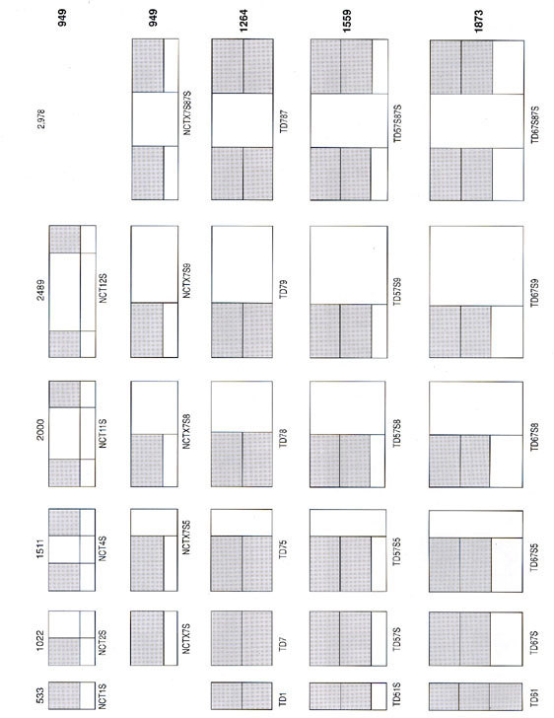

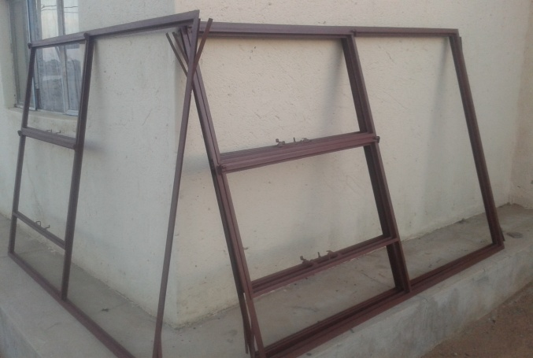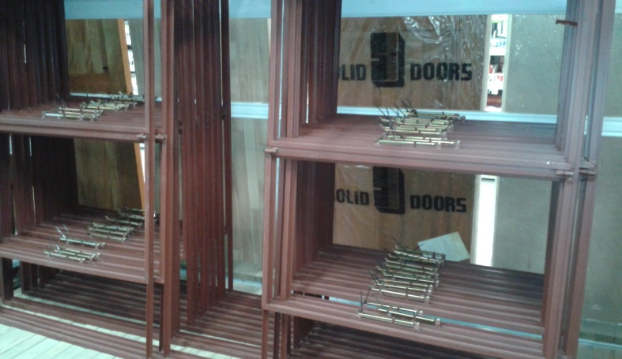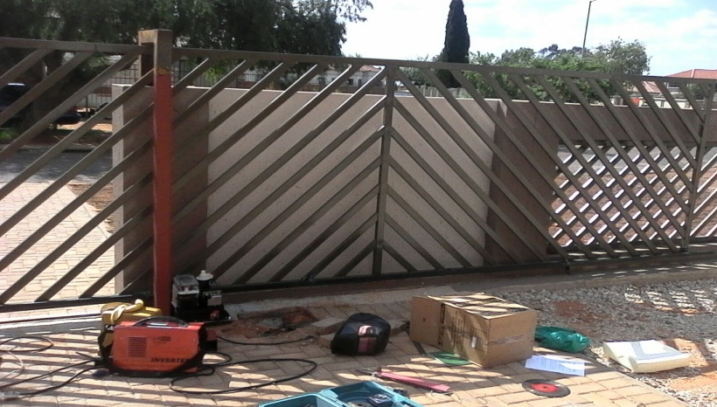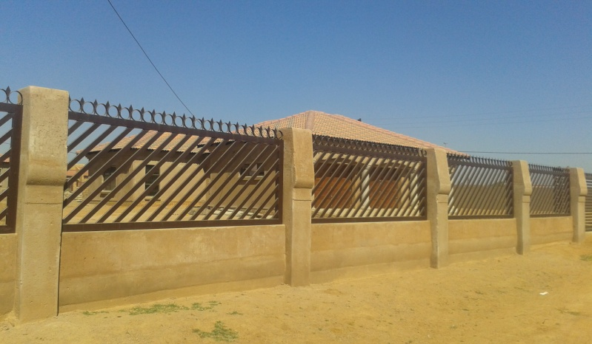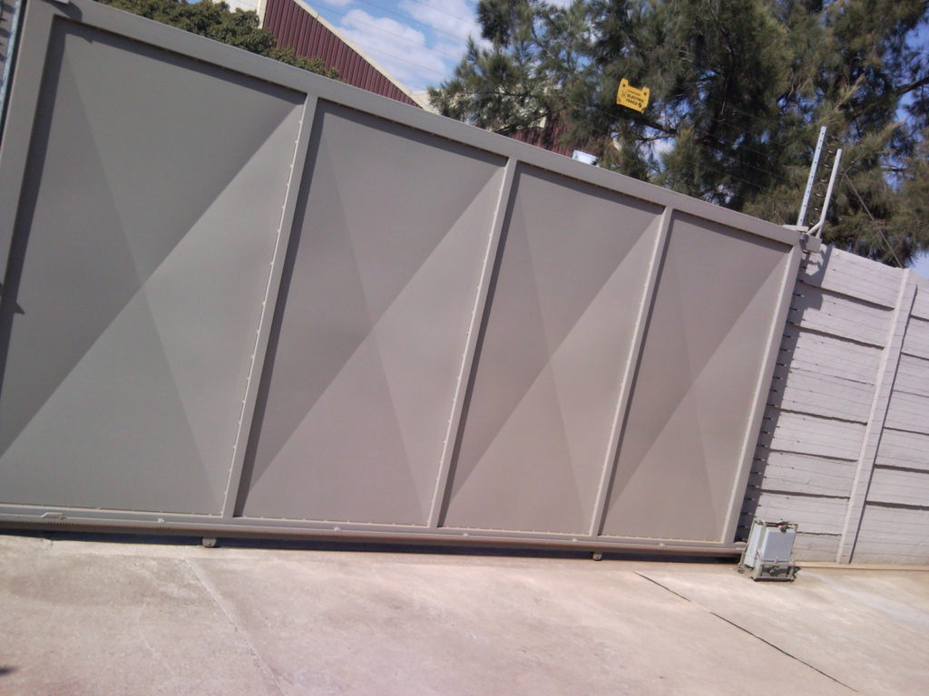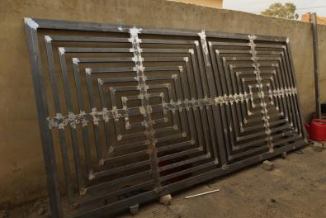

**ALUMINIUM**

MSS pride itself as the "new boys" in the Aluminium Window business. Entering a highly competitive market, our values of "customer first" and "innovation" has seen us achieve success amidst a very difficult financial climate.

Paramount to our immediate success is the formation of a highly competent customer-oriented team whose primary aim is to provide customers with excellent Quality and Exceptional Service. This team can design, manufacture and install a wide range of Aluminium Doors and Windows for residential, commercial and industrial developments. Our Aluminium range includes:

* Casement Windows (Top and Side hung)

* Vista Folding Doors

* Sliding Patio Doors

* Hinged Doors

* Entrance Doors

* Pivot Door

Our core target area is Mpumalanga, Gauteng and Limpopo, concentrating more on the main cities and towns. We are prepared to stop at nothing to ensure that our products reach the customers requiring our service.

All products are manufactured and installed in accordance with National Building

regulations as well as in accordance to the stringent standards administered by:

* AAAMSA (Association of Architectural Aluminium Manufacturers of South Africa)

* SAGGA (South African Glass and Glazing Association)

We guarantee complete peace of mind for years to come.

Trusting that Masango Steel Solutions can be of service to you in the near future

***We look forward to the challenge***

*For any queries regarding any of our services please contact:*

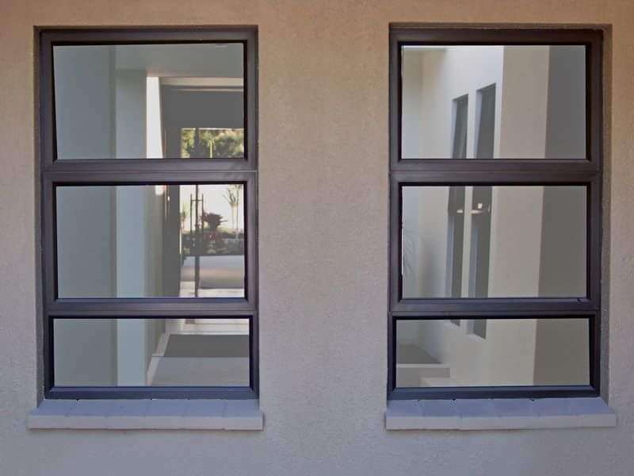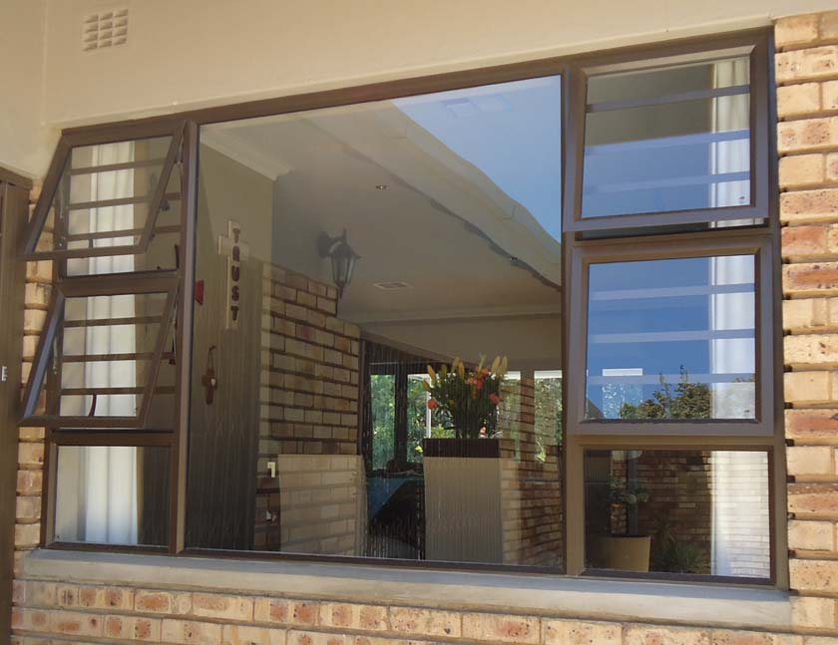**Brilliant Masango 079 465 5497**